P1. Repeat in PyMC the following experiment from Murphy (2012):

**Mixture of multinoullis**

We can use mixture models to define density models on many kinds of data. For example, suppose our data consist of D-dimensional bit vectors. In this case, an appropriate class-conditional density is a product of Bernoullis:

$$p\left(x_{i} | z_{i}=k,θ\right)= \prod_{j=1}^{D}{Ber(}x_{ij}\left|μ_{jk}\right)=\prod_{j=1}^{D}{μ_{jk}^{x_{ij}}{(1-μ_{jk})}^{1-x_{ij}}}$$

$$μ_{jk}=”the probability that bit j turns on in cluster k” (p. 340)$$

As an example of clustering binary data, consider a binarized version of the MNIST handwriting ten digit dataset (see Figure1.5(a)), where we ignore the class labels. We can fit a mixture of Bernoullis to this, using K=10, and then visualize the resulting centroids, ${\hat{μ}}_{k}$, as shown in Figure 11.5” (pp. 341-342).

Extras from (Murphy, 2012, p. 7):

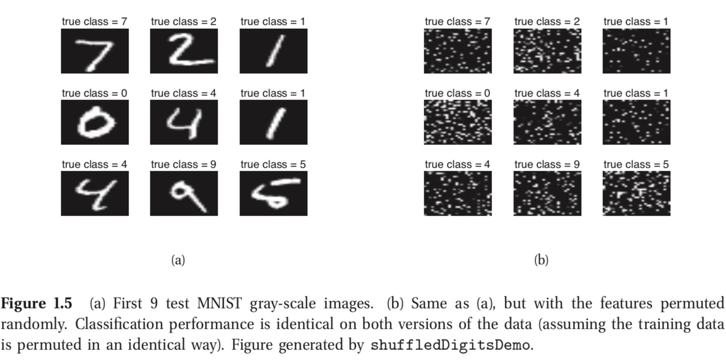

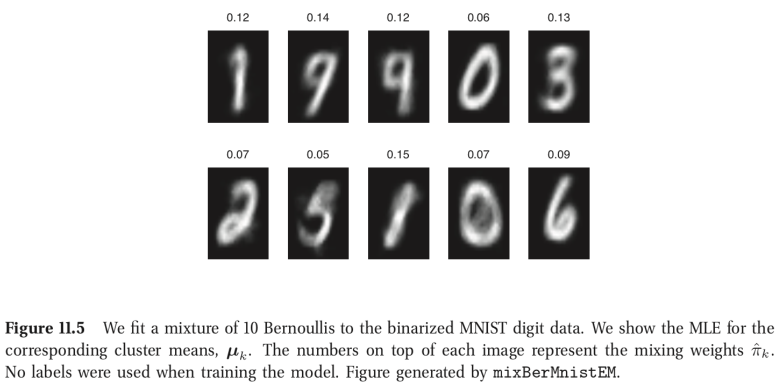

P2.

1. Use the program connected_waxman.py to generate 1000 random Waxman graphs (with alpha = 0.5 and beta = 0.1)
2. Use these graphs to infer alpha and beta. Comment the results.

# Cited works:

Murphy, K. P. (2012). *Machine Learning: A Probabilistic Perspective*. Cambridge: The MIT Press.